World wing chun cup 2016
29.04-1.05 2016 | Saint-petersburg | RUSSIA

Request for accommodatoin:

Group name:
City (Country)
Contact person:
Contact phone:
E-mail:

Dates: 29 APRIL - 1 MAY 2016

reservation form:

 | Name & Surname | Category of room | Date arrival | Date departure
1
2
3
4
5
6
7
8
9
10

VISA SUPPORT for tourist visa

Please send us copy of your passport (first page) (name, surname, sex, citizenship, date of birth, date of issue and expire)
We send you visa invitation letter and hotel reservation for Russian Consulate.

Visa support is free if you stay at the hotel. If you cancelled booking visa support – 25 EUR per person.

Please fill the form and send it to: iwcoworldcup16@mail.ru
We will send you confirmation back.
If you have Any questions – Dinaev Osman +7 950 007 93 38 / +7 965 762 04 02

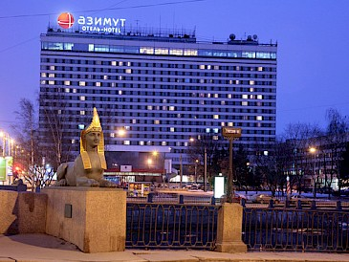

HOTEL Azimut Saint-Petersburg 3*
Address: Lermontovsky pr. 43/1
Metro station: Technologichesky institut
(check-in: 14:00 / check-out: 12:00)

http://azimuthotels.com/azimut_hotel_saint_petersburg
+7 (812) 740 26 40

Descriptions:

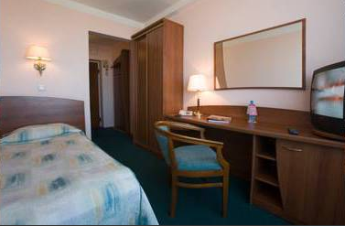
The AZIMUT Hotel Saint Petersburg is situated on the banks of Fontanka River in the historical center and is the tallest hotel in the city, boasting 1037 rooms, many with amazing views of St. Petersburg only an easy 5 kilometers from Nevsky Prospect and 13 kilometers to Pulkovo International and Domestic Airports. The location of the hotel allows excellent and easy transport links, including metro, taxis and cars with drivers to the city center, airports and all major attractions.

Standard single room:
Standard Twin or double Room:

Standard rooms offer between 11-14 sq. meters of space with single or twin or queen size beds and separate bathroom, including free Wi-FI. All rooms have separate work desk, satellite TV and direct dialing phone. Safety and security in the room is supported by electronic locking system and smoke detectors.

All price including 18% VAT, breakfast and visa support.

Transport services
Meet by coordinator at the airport or railway station and transfer to the hotel
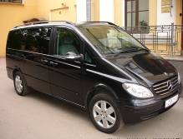
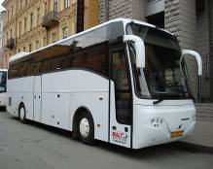
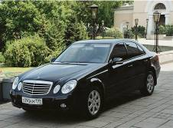

Price for the one-way transfer:

By CAR (till 3 pax) – 19 EUR for one-way transfer (airport-hotel)
By MINIBUS (from 4 till 20 pax) – 40 EUR for one-way transfer (airport-hotel)

Excursions

City sightseeing tour
3 hours, price upon request
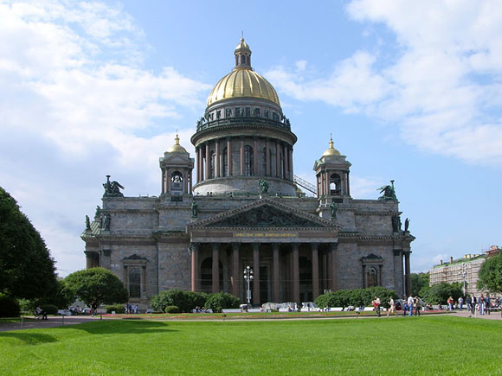
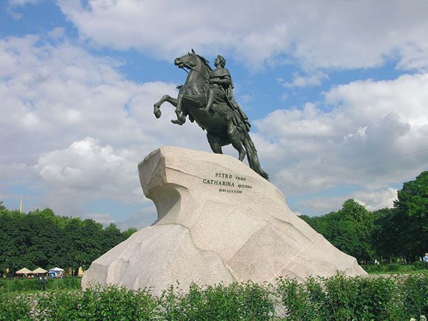
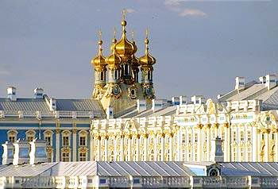

Descriptions:
The city sightseeing tour includes all major attractions of St. Petersburg. During the tour guests will be driven along the square of Arts, the Russian museums, the Cathedral of Our Savior on the Blood, Griboedov canal, Nevsky prospect, the Palace square, the Winter Palace, the spit of the Basil Island, the Menshikov Palace, the Senate square, the Bronze Horseman, St. Isaac’s Cathedral, St. Isaac’s square, The Palace Embankment, The Field of Mars, The Summer Garden, cruiser Aurora, Smolny Cathedral.

Tour to the Hermitage Art Museums with visit to the Treasure Gallery
3 hours, price upon request

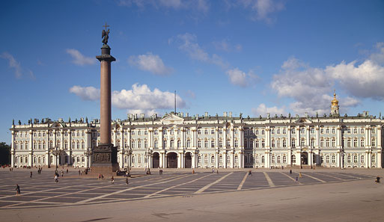
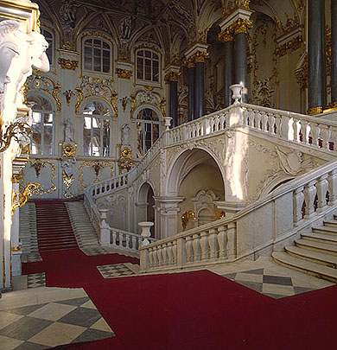
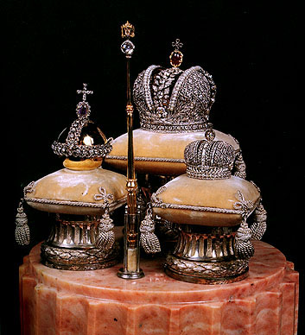

Descriptions:
The State Hermitage is situated along the embankment of the River Neva, right in the heart of St Petersburg. The leading role in this unique architectural ensemble is played by the Winter Palace, the residence of the Russian tsars that was built to the design of Francesco Bartolomeo Rastrelli in 1754-62.

The tour covers the highlights of the main collections including Italian Renaissance, Dutch art, Impressionists & Post-impressionists. It also the living quarters of the Royal family of the Romanov’s.

Tour to Tsarskoe Selo with visit to the Catherine Palace and Amber room
5 hours, price upon request

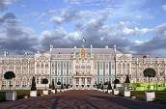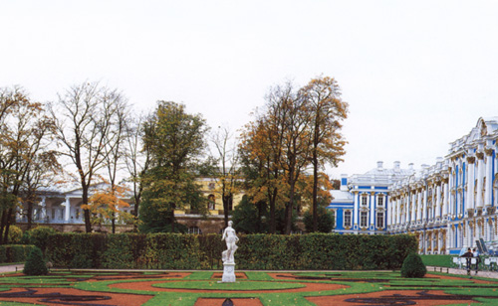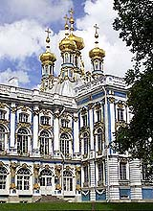

Descriptions:

The history of Tsarskoe Selo goes back to the beginning of the 18th century, when in 1708 Peter the Great presented the estate “Saari Mojs” (in future “Saarskoe Selo”) to his wife Catherine Alekseyevna.
The art collection of the Catherine Palace includes more than 20,000 objects, many of them extraordinary, such as Russian and Western European paintings from the 17th to 19th centuries, furniture designed by Chippendale, Jacob, Roentgen, Russian and Western European bronze and porcelain collection and the world-famous Amber Room.

